**TITLE OF LAB: (INTRODUCTION TO ZENER DIODE)**

**Lab No. #07**



**Spring 2022**

**CSE-206L Electronic Circuits Lab**

Submitted by

**Safi Ullah Khan : 20PWCSE1943**

Class Section: **B**

“On my honor, as student of University of Engineering and Technology, I have neither given nor received unauthorized assistance on this academic work.”

Student Signature: ______________

Submitted to:

**Engr. Abdullah Hamid**

(Monday, June 19th, 2022)

**Department of Computer Systems Engineering**

**University of Engineering and Technology, Peshawar**

**Objectives:**

* To study the characteristics of Zener diode.
* To study the voltage regulation in Zener diode regulation circuit.

**Equipment:**

* Voltmeter
* Ammeter
* Voltage source

**Components:**

* Resistors
* Zener Diode
* Ground

**Theory:**

**Diode:**

A diode is a two-terminal electronic component that conducts current primarily in one direction; it has low resistance in one direction, and high resistance in the other.

**Zener diode:**

* Zener Diode is a special type of Diode which operates at voltage equal to or greater than breakdown voltage.
* Zener diode is a P-N junction diode specially designed to operate in the reverse biased mode.
* It acts in both forward biased and in reverse biased.
* It is acting as normal diode while in forward biasing.
* It acts as voltage regulator in reverse biased.
* It has a particular voltage known as break down voltage, at which the diode break downs in reverse biased.
* In the case of normal diodes, the diode damages at the break down voltage and doesn’t work further more. But Zener diode is specially designed to operate in the reverse breakdown region.
* The basic principle of Zener diode is the Zener breakdown. When a diode is heavily doped, its depletion region will be narrow. When a high reverse voltage is applied across the junction, there will be very strong electric field at the junction. And the electron hole pair generation takes place. Thus, heavy current flows. This is known as Zener break down.
* So, a Zener diode, in a forward biased condition acts as a normal diode. In reverse biased mode, after the break down of junction current through diode increases sharply. But the voltage across it remains constant.

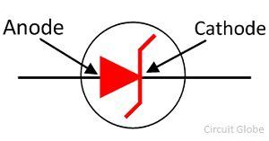

**Advantages:**

* The main advantage of Zener diode in real life is that, it is used is voltage regulator.

**Procedure:**

**Part A: Zener Diode Characteristics**

* Now we will draw given circuit in proteus and will see Zener Diode characteristic in reverse biased.
* As Zener diode is connected in reverse biased because in forward biased it act is normal diode so we will connect in reverse biased and see its characteristics.

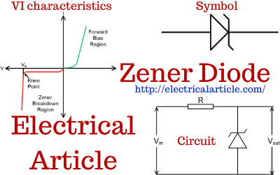

**Schematic Capture: (input Voltage less Than Breakdown Voltage)**

* As Zener diode is a diode which work at a voltage greater or equal to breakdown voltage.
* Here I consider the Zener diode its breakdown voltage is 20 volt and in given screenshot I apply 10 input voltage due to which the output current across the ammeter is zero. Its mean Zener Diode don’t work because breakdown voltage is less than breakdown voltage which is 20 in this case.
* Voltage drop across the resistor is zero. Total voltage appears at the output.

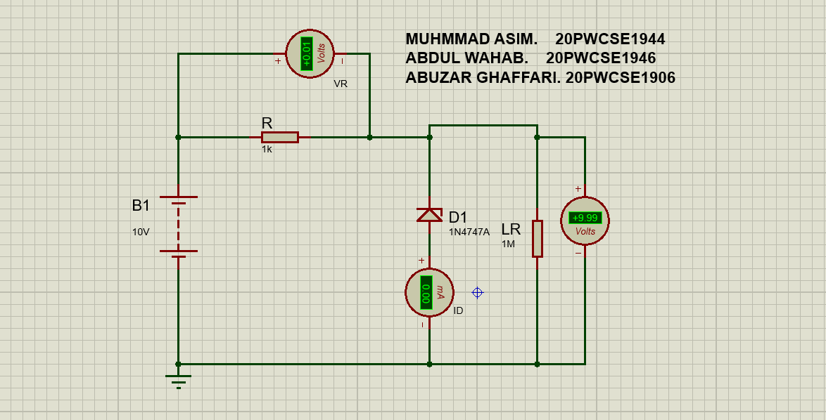

**Schematic Capture: (input Voltage greater than or equal to Breakdown Voltage)**

* Now the input voltage is greater than Breakdown Voltage so Zener Diode work properly.
* Only 20 volt appears at the output, remaining voltage drop across the resistor.
* In this case the output current is not zero.

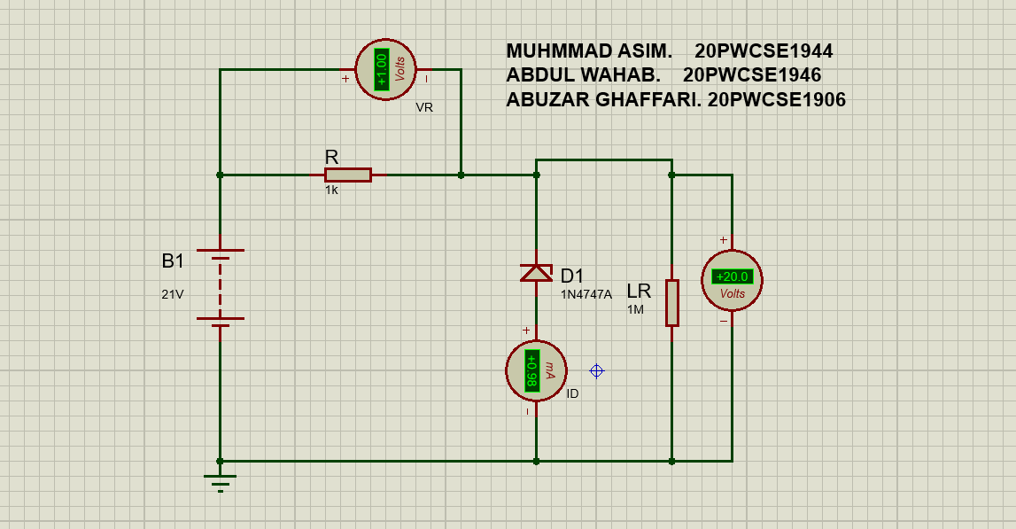

**Table: 1.1:**

* **In this table we are varying the input voltage while the output voltage remains constant.**
* The Zener Diode which I consider here Has Breakdown voltage=20v
* We see that at a given table the output voltage is 20v at different input voltages, its mean that in reverse biased the Zener Diode act as voltage regulator.
* At 10v Zener Diode don’t work.

|  |  |  |  |  |  |  |  |  |  |  |  |  |
| --- | --- | --- | --- | --- | --- | --- | --- | --- | --- | --- | --- | --- |
| Vin |  | 10v |  | 20v |  | 70v |  | 120v |  | 300v |  | 500v |
| Vout |  | 10v |  | 19.9v |  | 20.1v |  | 20.1v |  | 20.2v |  | 20.2v |
| VR |  | 0v |  | 0.07v |  | 49.9v |  | 99.9v |  | 280v |  | 480v |
| ID=VR/R |  | 0A |  | 0.07A |  | 49.9A |  | 99.9A |  | 280A |  | 480A |

**Part A: Zener Diode as voltage Regulator:**

* The given circuit is real voltage regulator circuit.
* In real life load resistor is a device.
* In above table 1.1 we were changing the value of input voltage but here we will keep it constant and will change the value of load resistor and note the output voltage.

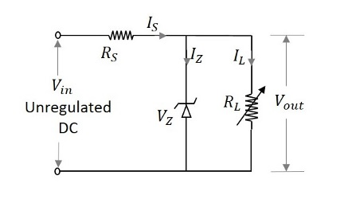

**Proteus Schematic: (RL>threshold resistance)**

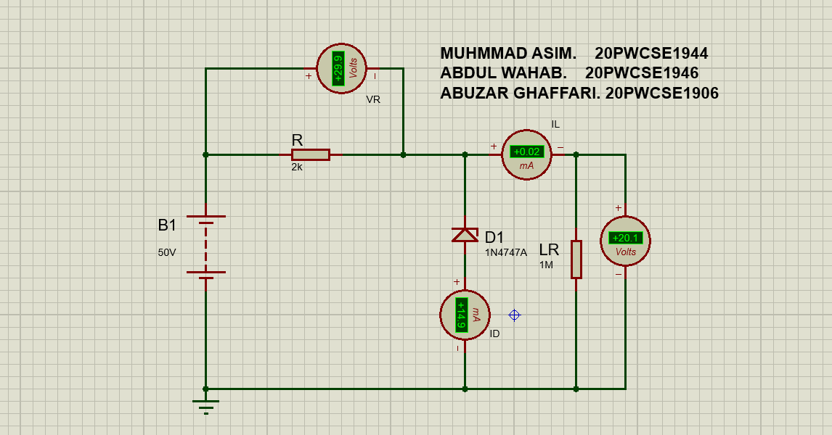

**Proteus Schematic: (RL<threshold resistance)**

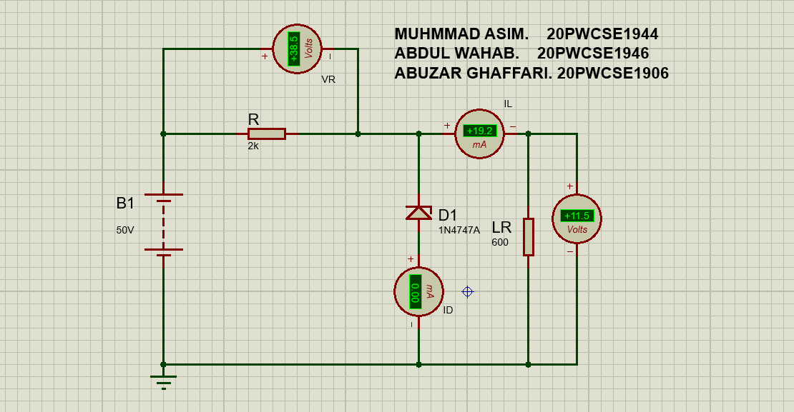

**Table: 1.2:**

* Input voltage remains constant.
* The Zener diode which I consider here has breakdown voltage=15V.
* As we are varying the load resistance but the output voltage remains constant, so it is called voltage regulator.
* At 600 ohm the Zener diode don’t work I, e the output voltage is not 15v also current across the Diode is zero.
* Its mean that each Zener Diode has a threshold level of resistance. Below the threshold level the Zener Diode doesn’t work while above the threshold level it works properly.

|  |  |  |  |  |  |  |  |  |  |  |  |  |
| --- | --- | --- | --- | --- | --- | --- | --- | --- | --- | --- | --- | --- |
| Vin |  | 50v |  | 50v |  | 50v |  | 50v |  | 50v |  | 50v |
| RL ohm |  | 1M |  | 50k |  | 10k |  | 5k |  | 1k |  | 600 |
| Vout |  | 15.1v |  | 15.1v |  | 15.1v |  | 15.1v |  | 15v |  | 11.5 |
| VR |  | 34.9v |  | 34.9v |  | 34.9v |  | 34.9v |  | 35v |  | 38.5 |
| ID |  | 17.4A |  | 17.2A |  | 16A |  | 14.5A |  | 15A |  | 0.0A |
| IL |  | 0.01A |  | 0.30A |  | 1.51A |  | 3.01A |  | 2.48A |  | 19.2A |

**How to calculate the threshold Level of Load Resistor (RL):**

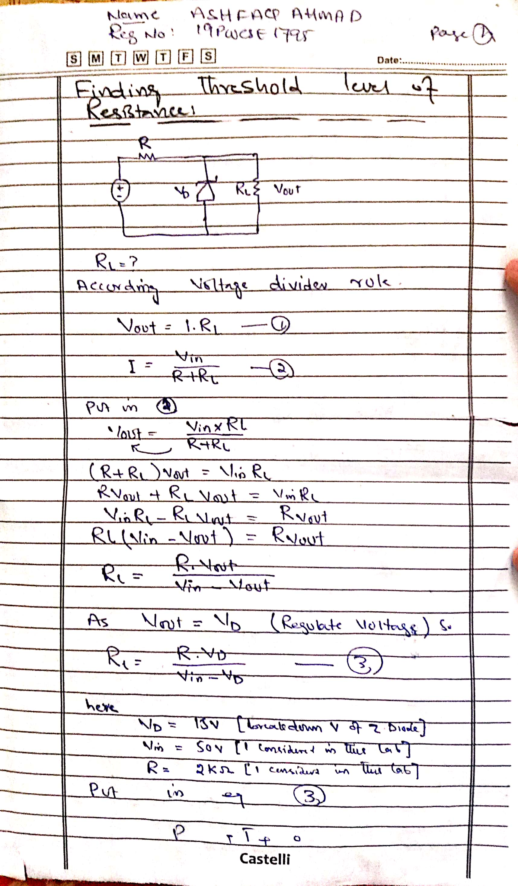

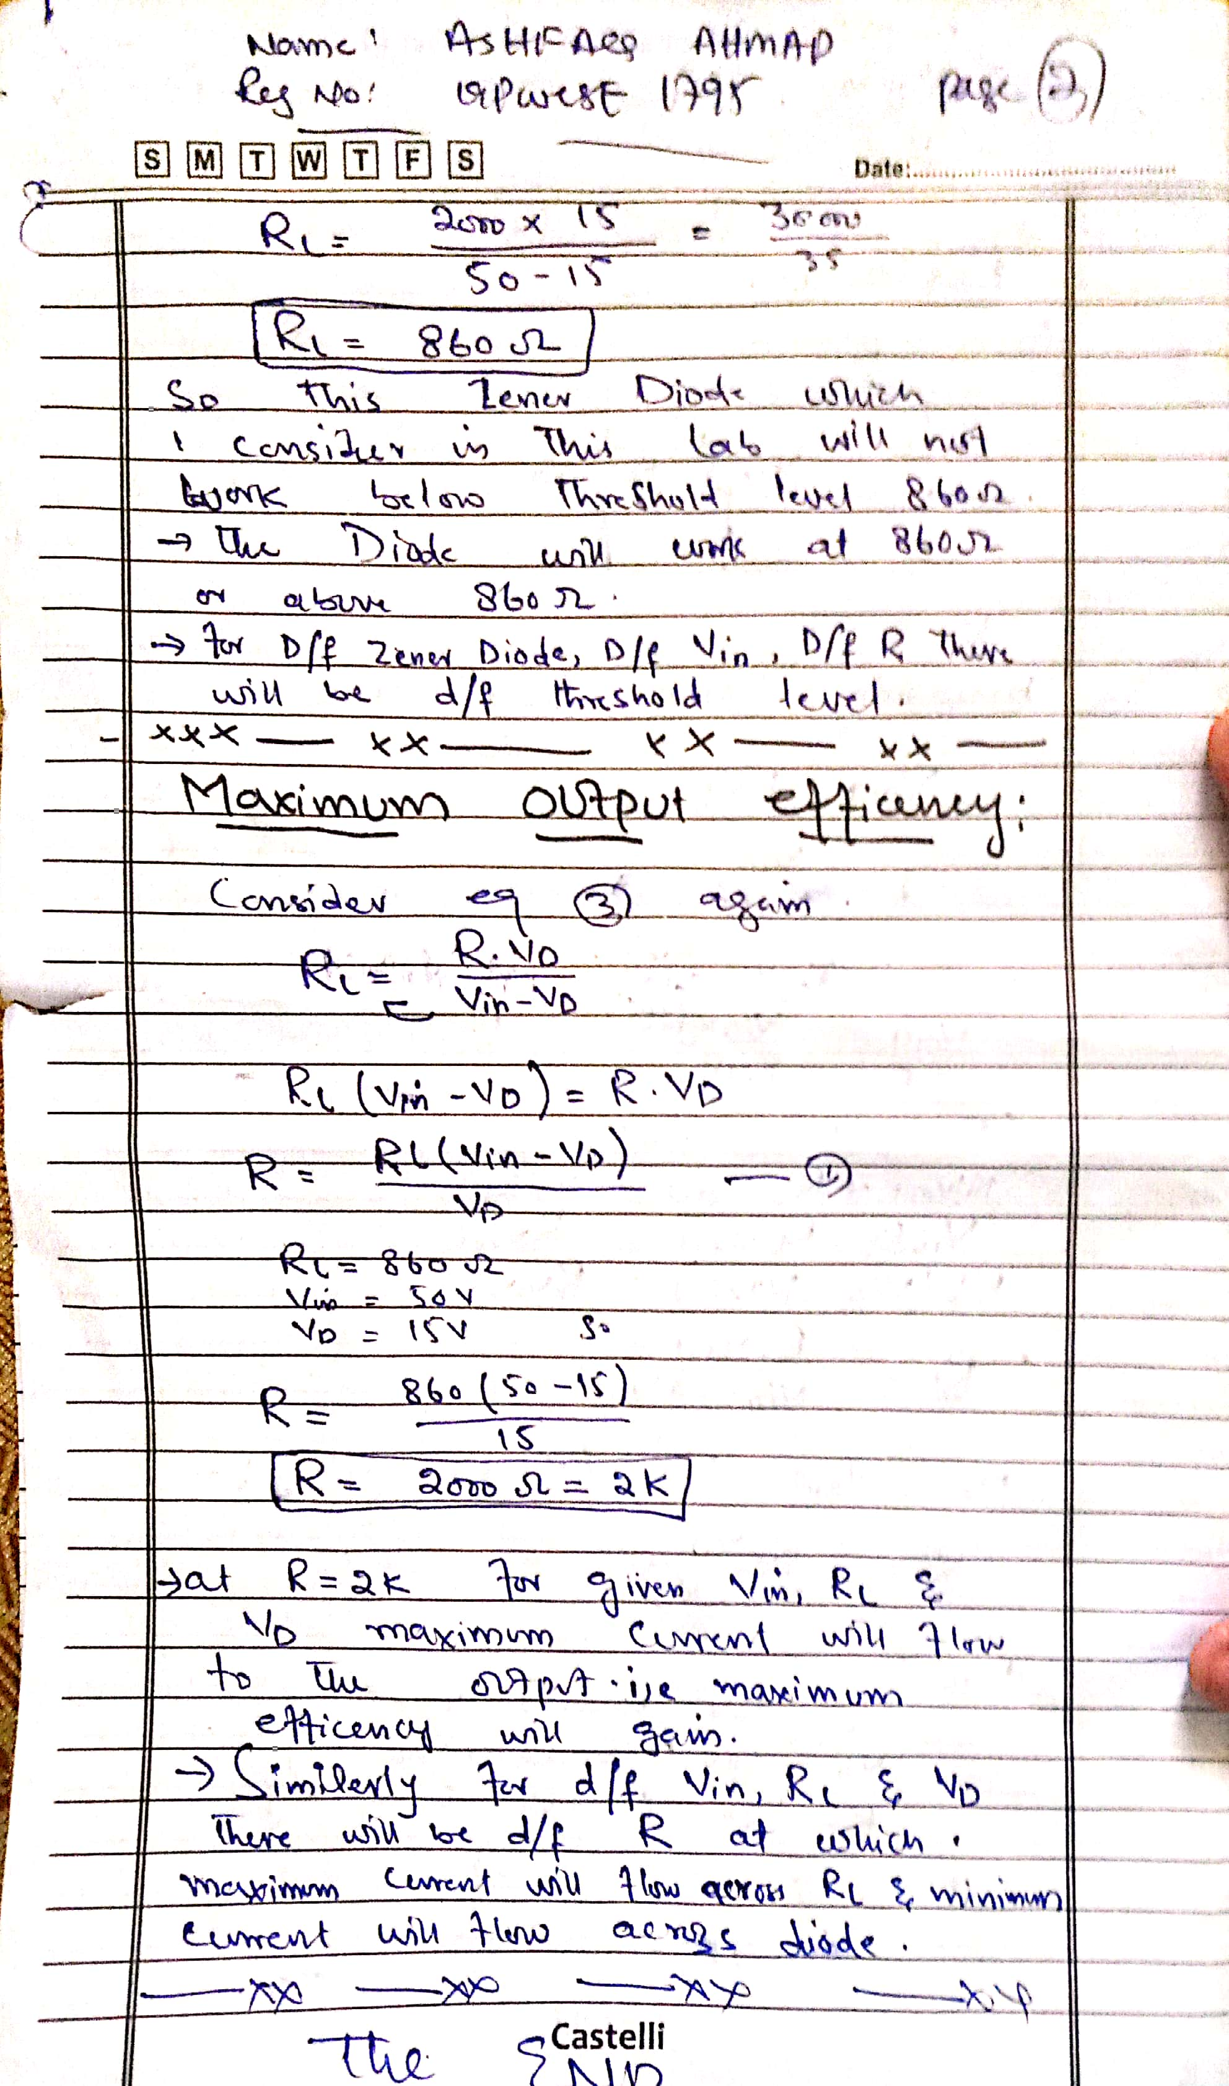

**Maximum Efficiency:**

* At R=2k for Vin=50v, VD=15v, RL=860 ohm the maximum current flow to the output while minimum current flow across Zener Diode.

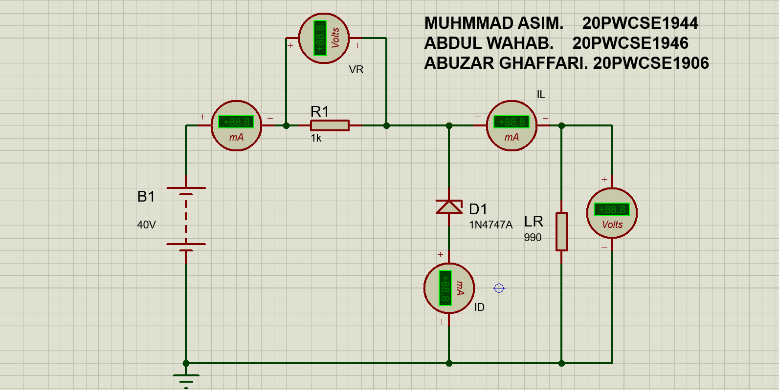

**---------------------------------THE END--------------------------------**